PLEASE NOTE:

The highlighted boxes need to be INITIALED.
X’s will not be accepted by the facility.

Please see the instructions on the following page.
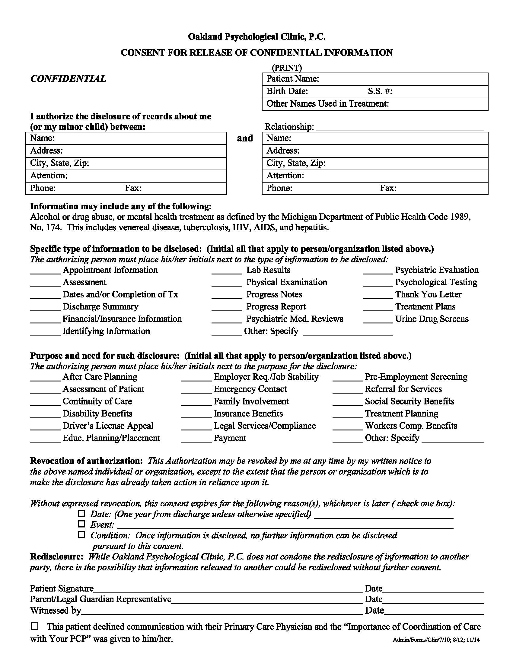
University of Michigan Hospital and Health Center
2901 Hubbard Street Room 2722
Ann Arbor, MI 48109-0000
Release of Information Unit - NCAC
(734) 936-5490
(734) 936-8571
Batman
01/01/1979
xxx-xx-5555

Axiom Requisition Copy Service
2869 Jolly Road
Okemos, MI 48864
Records
(877) 886-5090
(517) 886-4116
x
End of Litigation

Order No. 01-29018 - 002

